**Linear Integrated Circuits & Applications Lab**

A MINI PROJECT REPORT

ON

**SMART TROLLEY USING 555 TIMERS**

**Submitted By**

|  |  |
| --- | --- |
| **Sanjana .G. Rao** | **(4NM17EC136)** |
| **Sarthak** | **(4NM17EC138)** |
| **Sathwik .K. Kunder** | **(4NM17EC139)** |

**November 2019**

|  |
| --- |
| **DEPARTMENT OF ELECTRONICS AND COMMUNICATION ENGINEERING** |



TABLE OF CONTENTS

TABLE OF CONTENTS ii

List of Tables iii

List of Figures iv

1. Introduction 1

2. Block Diagram 2

3. Circuit DESIGN 3

4. Testing Scheme 10

5. Project Outcome’s 13

REFERENCES 14

List of Tables

Table 3‑1: Truth Table for the Person and Obstacle Detection 4

Table 3‑2: Truth Table for the output of the project 4

List of Figures

Figure 2‑1: Block diagram of the project 2

Figure 3‑1: Circuit diagram of the project 3

Figure 3‑2: Logic Diagram for Table 3-1 4

Figure 3‑3: Logic Diagram for Table 3-2 5

Figure 3‑4: 555 Timer IC 5

Figure 3‑5: Infrared Sensor 6

Figure 3‑6: L293D Motor Driver 6

Figure 3‑7: Dual Shaft Motor 6

Figure 3‑8: Voltage Regulator 7

Figure 3‑9: Capacitors 7

Figure 3‑10: Diode 1N4007 7

Figure 3‑11: Resistors 8

Figure 3‑12: IC7408(AND Gate) 8

Figure 3‑13: IC7404(NOT Gate) 8

Figure 3‑14: Jumper Wires 8

Figure 3‑15: General Purpose PCB 9

Figure 4‑1: Driving the motor 10

Figure 4‑2: Controlling the motor through sensors 10

Figure 4‑3: Making of the bot 11

Figure 4‑4: Implementing on breadboard 11

Figure 4‑5: Designing of the track and testing 11

Figure 4‑6: Implementing on PCB 12

# Introduction

Today’s world has a fast-growing population with a wide range of demand from a variety of domains. In the advancement of technologies, the world is getting automated in many aspects. In this project, we depict reasonable Smart Shopping Cart utilizing 555 timer circuits and sensors. Such a framework is appropriate for use in spots such as supermarkets.

According to statistics, around 24.13% of billion-dollar companies have invested a lot of money on this idea and came with robotic carts which cost a fortune and therefore it was possible only for big supermarkets to implement it, but it is on working progress. Hence, we have come with a design for smart trolley using basic components to reduce the price of the cart so it can be made use by almost all supermarkets, big or small to upgrade the shopping experience of the customers.

Overall, this system will ensure that the customers will have the best and convenient shopping experience. Rather than influencing the clients to hold the shopping cart and push it every time to follow them, this framework helps in mechanizing the easy and comfortable line following process by detecting black path on the floor and thereby following it.

.

# Block Diagram

ASTABLE MULTIVIBRATOR 1

PERSON DETECTING CIRCUIT

LINE DETECTING CIRCUIT

MOTOR 1

MOTOR 2

OBSTACLE DETECTING CIRCUIT

ASTABLE MULTIVIBRATOR 2

Figure 2‑1: Block diagram of the project

Our proposed system contains 2 main parts, a line detecting block and shopper/obstacle detecting block. Line detecting block helps the cart to follow a particular path detecting the line, the line is coated with the color which can absorb more light than the surrounding color of the floor. The block detects the path and helps the cart trace the line. Shopper detecting block detects the shopper handling the cart and helps the cart to follow the shopper’s movements. With this added feature, we have an approach where the cart follows the shopper, therefore if the shopper halts at a particular place, the cart will halt too making the shopper place the item on cart conveniently. Moreover, the cart also has an obstacle detecting block which stops the cart in case an obstacle is detected in the front of the cart. These features save time and make shopping easy.

# C:\Users\User\Desktop\WhatsApp Image 2019-11-13 at 9.54.34 AM.jpeg**Circuit DESIGN**

Figure 3‑1: Circuit diagram of the project

* 1. **Circuit Design:**

The circuit is designed for 90% Duty Cycle. We know,

*Duty Cycle* = 3-1

0.9 =

0.9R1 + 0.9R2 = R1

0.9R2 = 0.1R1

R1= 9R2 3-2

Assuming the frequency as 1 KHz and C2 = 0.1µF

*f =*  3-3

1k =

R2= 1.45kΩ (Choose **R2= 1.5 kΩ** standard value)

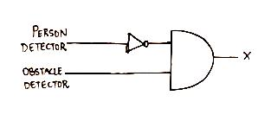R1 = 13.05 kΩ (Choose **R1 = 12 kΩ** standard value)

**Figure 3‑2: Logic Diagram for Table 3-1**

**Table 3-1: Truth Table for the Person and Obstacle Detection**

|  |  |  |
| --- | --- | --- |
| **Person Detector** | **Obstacle detector** | **Output (X)** |
| **0** | **0** | **0** |
| **0** | **1** | **1** |
| **1** | **0** | **0** |
| **1** | **1** | **0** |

**Table 3-2: Truth Table for the output of the project**

|  |  |  |
| --- | --- | --- |
| **IR SENSOR INPUT** | **X** | **OUTPUT (Y)** |
| **0** | **0** | **0** |
| **0** | **1** | **0** |
| **1** | **0** | **0** |
| **1** | **1** | **1** |

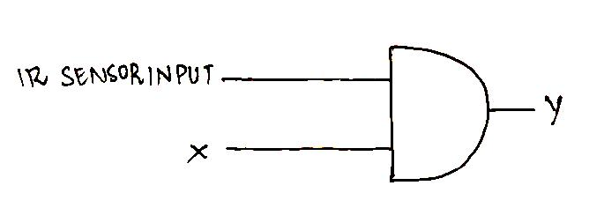

**Figure 3‑3: Logic Diagram for Table 3-2**

* 1. **Circuit Description:**

Four IR Sensors are used in which two are used for Line following circuit, one is for person detection and other is for obstacle detection. The circuit consists of two 555 timers operating in astable mode. The timers are designed for the duty cycle of 90% and frequency 1 kHz. Output of the all the sensors are given to the enables of the L293D motor driver respectively by ANDing the outputs of person detecting and obstacle detecting sensors and later by ANDing the results of sensors to the line following sensors. Outputs of the two astable multivibrators are given to two inputs of the L293D motor driver respectively. Output of the motor drivers makes the wheels of the bot rotate thus making it follow the desired path.

**3.3. Components Required:**

1. 555 Timers

The 555 timer IC is an [integrated circuit](https://en.wikipedia.org/wiki/Integrated_circuit) (chip) used in a variety of [timer](https://en.wikipedia.org/wiki/Timer), pulse generation, and [oscillator](https://en.wikipedia.org/wiki/Electronic_oscillator) applications. The 555 can be used to provide time delays, as an [oscillator](https://en.wikipedia.org/wiki/Oscillator), and as a [flip-flop element](https://en.wikipedia.org/wiki/Flip-flop_element). The 555 timer used in our project is configured as an astable circuit. This means that the output voltage is a periodic pulse that alternates between the VCC value and 0 volts.

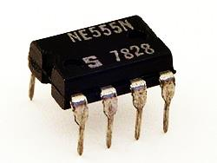

Figure 3‑4: 555 Timer IC

1. Infrared Sensors (IR Sensors)

An [infrared sensor](https://www.elprocus.com/ir-remote-control-basics-operation-application/) is an electronic device that emits in order to sense some aspects of the surroundings. An IR sensor can measure the heat of an object as well as detects the motion. These types of sensors measure only infrared radiation, rather than emitting it that is called as a [passive IR sensor](https://www.elprocus.com/passive-infrared-pir-sensor-with-applications/).

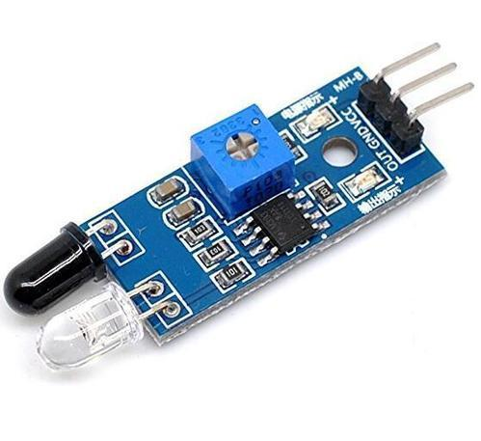

Figure 3‑5: Infrared Sensor

1. L293D Motor Driver

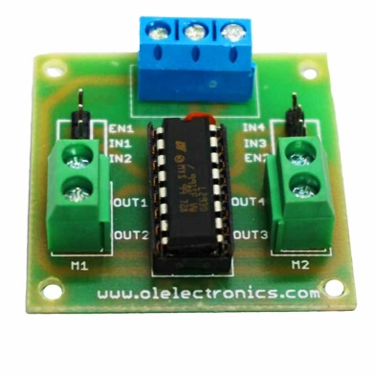L293D is a typical Motor driver or Motor Driver IC which allows DC motor to drive on either direction. L293D is a 16-pin IC which can control a set of two DC motors simultaneously in any direction. It means that you can control two [DC motor](https://www.rakeshmondal.info/High-Torque-Motor-Low-RPM-Motor) with a single L293D IC. Dual H-bridge Motor Driver integrated circuit*(*IC*).*

Figure 3‑6: L293D Motor Driver

1. Dual Shaft Motor

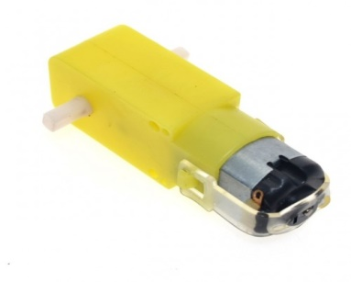Low current operated DC motor with plastic gear head. Ideal for low to medium torque application with battery operated systems. RPM - Approx. 300 at 12V.

**Figure 3‑7: Dual Shaft Motor**

1. Voltage Regulator

A voltage regulator is a system designed to automatically maintain a constant voltage level. A voltage regulator may use a simple feed-forward design or may include negative feedback. It may use an electromechanical mechanism, or electronic components.

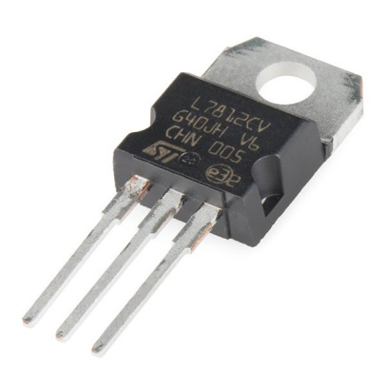

**Figure 3‑8: Voltage Regulator**

1. Capacitors

A capacitor is a device that stores electrical energy in an electric field. It is a passive electronic component with two terminals. The effect of a capacitor is known as capacitance.

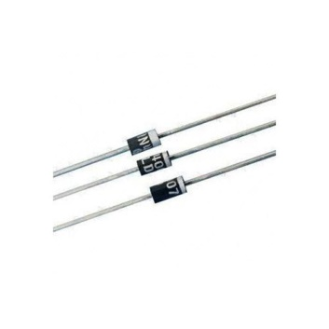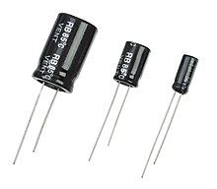

**Figure 3‑9: Capacitors Figure 3‑10: Diode 1N4007**

1. Diode 1N4007

Diode 1N007 is used for reverse voltage protection, a staple for many powers, DC to DC step up, and breadboard projects. 1N4007 is rated for up to 1A/1000V. A diode allows electrical current to flow in one direction - from the anode to the cathode. Some diodes, such as the 1N4007 will break down at 1000V.

1. Resistors

A resistor is a passive two-terminal electrical component that implements electrical resistance as a circuit element. In electronic circuits, resistors are used to reduce current flow, adjust signal levels, to divide voltages, bias active elements, and terminate transmission lines, among other uses.

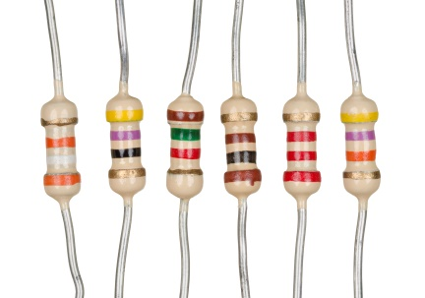

**Figure 3‑11: Resistors**

1. IC7408 (AND Gate)

The 7408 is a QUAD 2-Input AND gates and contains four independent gates each of which performs the logic AND function.

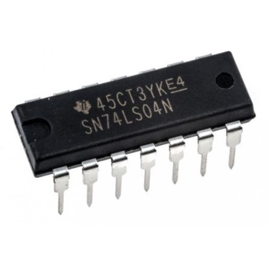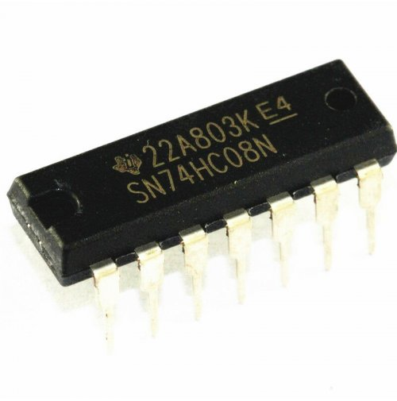

**Figure 3‑12: IC7408 (AND Gate) Figure 3‑13: IC7404 (NOT Gate)**

1. IC7404 (NOT GATE)

7404 is a NOT gate IC. It consists of six inverters which perform logical invert action. The output of an inverter is the complement of its input logic state, i.e., when input is high its output is low and vice versa.

1. Jumper Wires

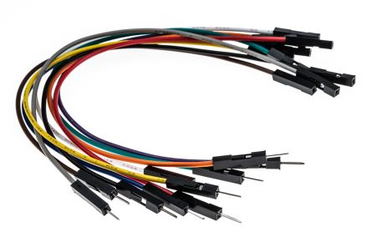Jumper wires are simply wires that have connector pins at each end, allowing them to be used to connect two points to each other without soldering. Jumperwires are typically used with breadboards and other prototyping tools in order to make it easy to change a circuit as needed.

**Figure 3‑14: Jumper Wires**

1. 9V Battery

The nine-volt battery, or 9-volt battery, is a common size of battery that was introduced for the early [transistor radios](https://en.wikipedia.org/wiki/Transistor_radio). It has a rectangular prism shape with rounded edges and a polarized snap connector at the top. This type is commonly used in [walkie-talkies](https://en.wikipedia.org/wiki/Walkie-talkie), [clocks](https://en.wikipedia.org/wiki/Clock) and [smoke detectors](https://en.wikipedia.org/wiki/Smoke_detector).

1. General Purpose PCB

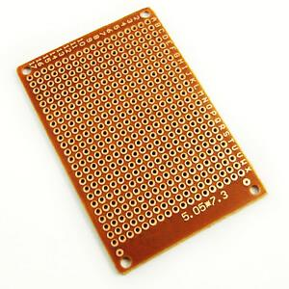PCB is an acronym for printed circuit board. It is a board that has lines and pads that connect various points together. In the picture above, there are traces that electrically connect the various connectors and components to each other. A PCB allows signals and power to be routed between physical devices.

**Figure 3‑15: General Purpose PCB**

4. Testing Scheme

* Testing Point 1: Driving the motor.

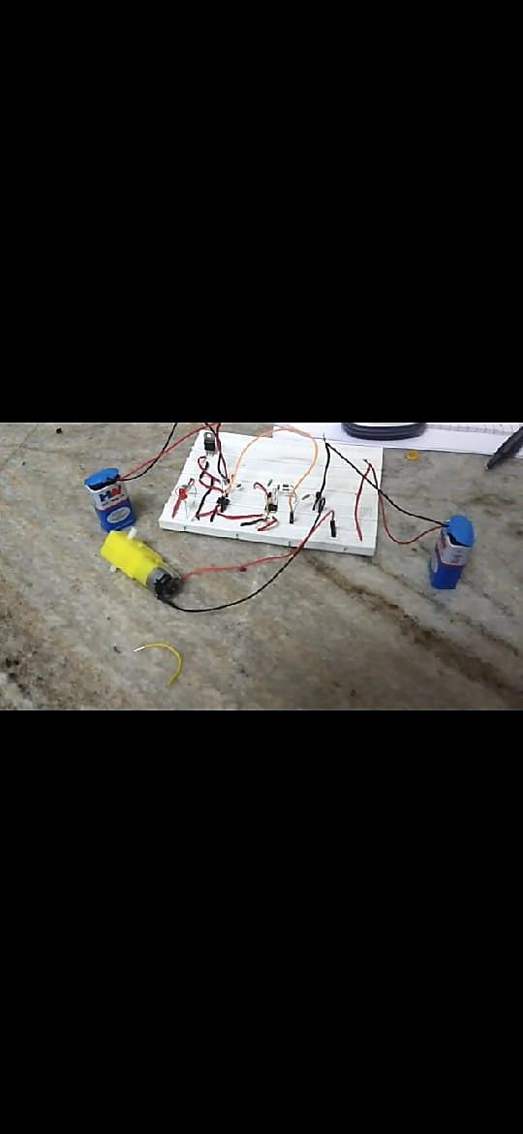Driving the motors using two 555 timers in astable mode of 90% Duty Cycle and 1 KHz frequency.

**Figure 4‑1: Driving the motor**

* Testing Point 2: Controlling the motor through sensors.

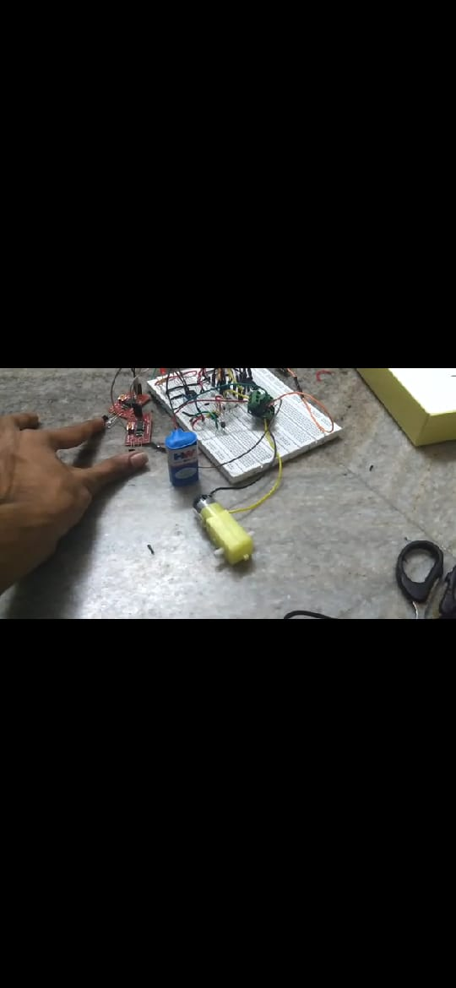Controlling the motors through 4 IR sensors (2 line detecting,1 obstacle detecting and 1 person detecting).

**Figure 4‑2: Controlling the motor through sensors**

* Testing point 3: Making the bot.

Combining the first two phases to design a bot of given specifications to a L293D motor driver to rotate the wheels of the bot.

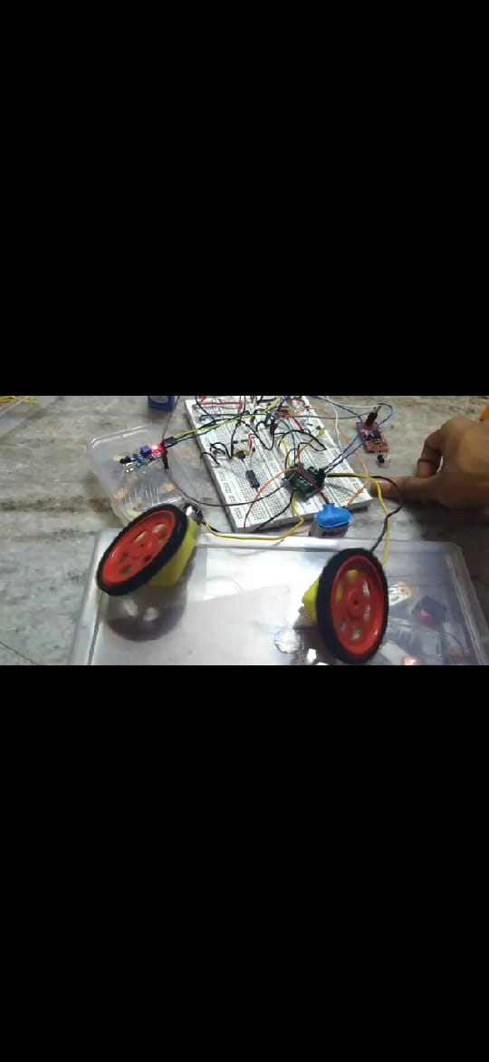

**Figure 4‑3: Making of the bot**

* Testing Point 4: Designing the track/path.

The desired path is designed by drawing a circular path on a white chart paper and then covering the circular path with a black tape in order for the sensor in the bot to differentiate between the reflecting surface and non-reflecting surface and follow accordingly.

* Testing Point 5: Implementing on breadboard.

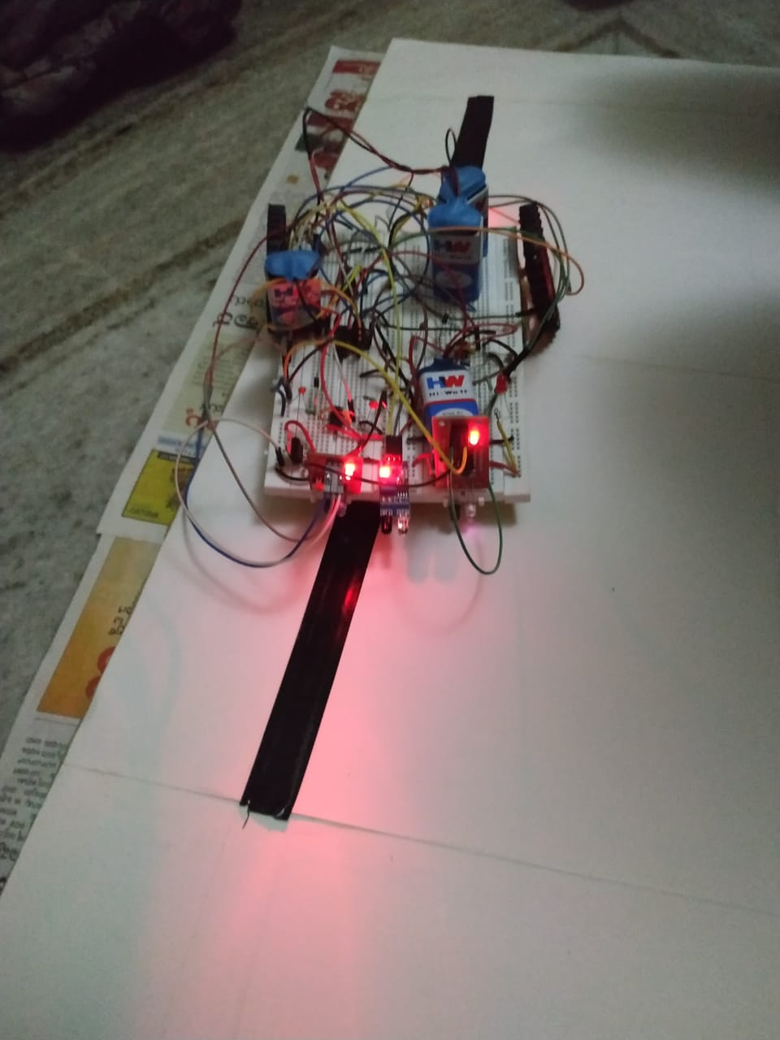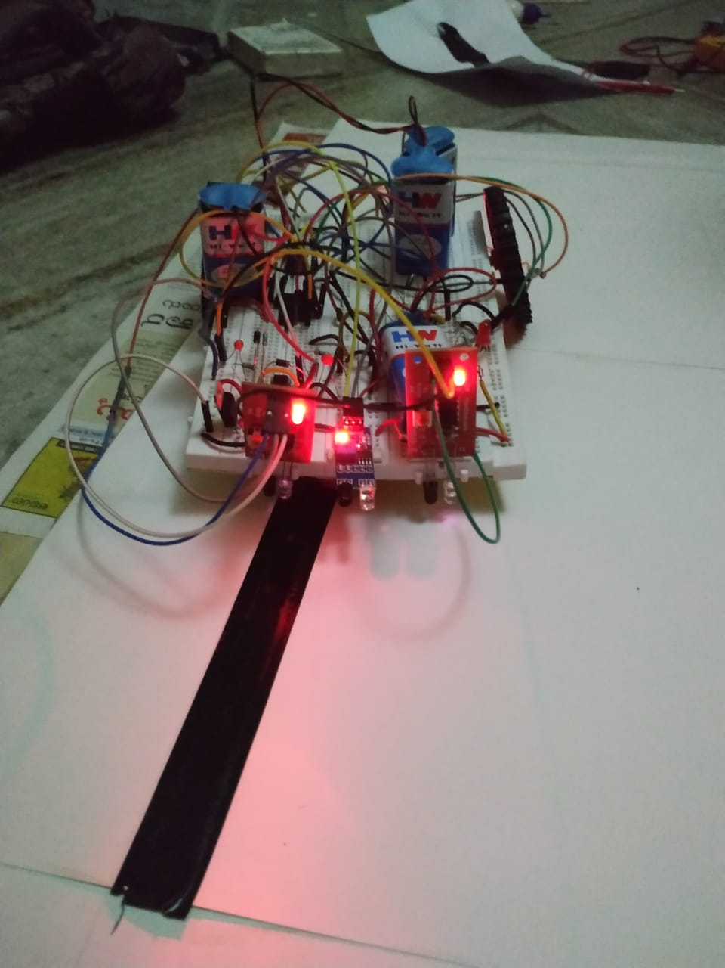The circuit is then implemented on the breadboard and is checked for necessary shorts and is tested for working.

**Figure 4‑4: Implementing on breadboard**

**Figure 4‑5: Designing of the track and testing**

* Testing Point 6: Implementing on PCB.

Once the designed output is obtained in the breadboard, the same is implemented on PCB for the given specifications. Soldered the components as per circuit diagram, checked whether there was any unwanted short occurred due to soldering and also checked for continuity of the wires using multimeter.

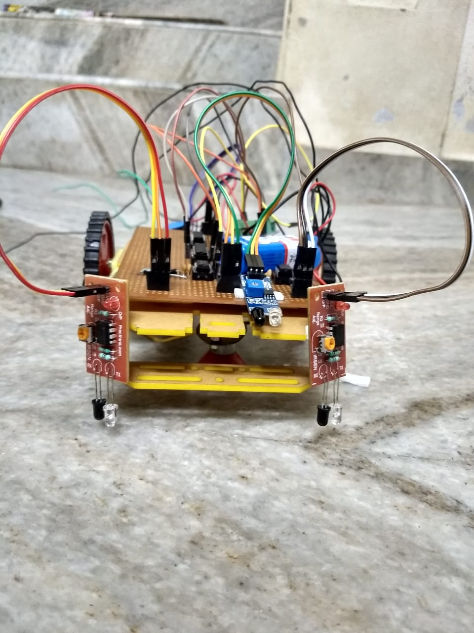

**Figure 4‑6: Implementing on PCB**

# Project Outcome’s

The Line Follower circuit is rigged up in a PCB Board and is tested to detect and follow the black colored line on the floor. Accordingly, the Person Detecting Circuit and the Obstacle Detecting Circuit are tested to detect the presence of a person and an obstacle and make the Line follower circuit stop in the absence of a person and in presence of an obstacle.

REFERENCES

.

1. Astable Multivibrators using 555 Timers, "Op Amps and Linear Integrated Circuits", By Ramakant A. Gayakwad, Paperback, Pearson Education; Fourth edition (29 May 2015).
2. <https://www.electronicshub.org/ir-sensor/>.
3. 555 Timers, Infrared Sensors, Voltage Regulators,Motors,L293D motor driver, capacitors, diode 1N4007, resistors, PCB Board, Jumper wires, 9V battery, IC7408,IC7404 images by – google images.
4. <http://rookieelectronics.com/lfr-using-555-timer/>

x

x

|  |  |  |
| --- | --- | --- |
|  | **Evaluator** | **Signature** |
| **1** |  |  |
| **2** |  |  |